2020 IEEE International Students' Conference on Electrical, Electronics and Computer Science

Smart Farming System using IoT for Efficient Crop Growth

Abhiram MSD1 Department of ECE

Chaitanya Bharathi Institute of Technology(A*)*

Hyderabad, India [abhirammsd@gmail.com](mailto:abhirammsd@gmail.com)

Jyothsnavi Kuppili2 Department of ECE

Chaitanya Bharathi Institute of Technology(A*)*

Hyderabad, India [joshi1772000@gmail.com](mailto:joshi1772000@gmail.com)

N.Alivelu Manga3 Department of ECE

Chaitanya Bharathi Institute of Technology(A*)*

Hyderabad, India [namanga04@gmail.com](mailto:namanga04@gmail.com)

***Abstract*— Smart agriculture is a farming system which uses IoT technology. This emerging system increases the quantity and quality of agricultural products. IoT devices provide information about nature of farming fields and then take action depending on the farmer input. In this paper, an IoT based advanced solution for monitoring the soil conditions and atmosphere for efficient crop growth is presented. The developed system is capable of monitoring temperature, humidity, soil moisture level using NodeMCU and several sensors connected to it. Also, a notification in the form of SMS will be sent to farmer’s phone using Wi-Fi about environmental condition of the field.**

**Keywords—*IoT, NodeMCU, agriculture, sensors***

1. INTRODUCTION

Agriculture is the primary occupation in India and is the backbone of Indian economic system. Agriculture provides employment opportunities to rural people on a large scale in underdeveloped and developing countries in addition to providing food. It is the process of producing food, fiber and many other desired products by the cultivation and raising of domestic animals. Agriculture is the primary source of livelihood for about more than 58% of India’s population.

Climate changes will have significant impact on agriculture by increasing water demand and limiting crop productivity in areas where irrigation is most needed. Irrigation system, rain fed agriculture, groundwater irrigation are some of the methods introduced to produce healthier crops which may not use water efficiently. In order to use water efficiently a smart system is designed. In the system farmer need not make the water flow into fields manually, but the system automatically does that efficiently.

The traditional methods practiced by people may result in huge wastage of water. Hence, the concept of robotized farming with mix of IoT has been developed [1]. The technological advancements began to increase the efficiency of production remarkably thus, making it a reliable system. The knowledge of properties of soil determines the water supply to be driven in a smart way. The practice of agriculture in a smart way helps to acquire knowledge of soil and temperature conditions. Developing the smart agriculture using IoT based systems not only increases the production but also avoids wastage of water [2]. The soil moisture sensor, humidity and temperature sensor continuously

monitors the soil and environmental conditions, sends the live data to smartphone via cloud service.

While raining, the moisture content may increase several times. A rain-drop detecting sensor intimates the controller if there is rainfall, making the water supply to reduce or stop depending upon the moisture content at the moment. The crop requirements such as amount of humidity, temperature and moisture content are to be studied and can be installed again in the controller to meet its circumstances.

In this paper, the system uses few sensors which gives the amount of moisture in the soil, the humidity and temperature of the region, and a rain detecting sensor which and can be used in deciding whether the crop is suitable for growing. All these sensors along with NodeMCU are connected to the internet and a smartphone.

1. PROPOSED SMART FARMING SYSTEM

The system proposed uses a microcontroller (NodeMCU) which has a Wi-Fi module (ESP8266) over it. Smartphone with blynk is used as user interface. Soil moisture sensor, humidity and temperature sensor (DHT11) and rain detection sensors along with DC motor and deek robot are used. This DC motor is connected to a water pump which pumps water to the crops when the DC motor is ON. The soil moisture sensor senses the moisture level in the soil [3]. Depending on the level of moisture, NodeMCU decides whether to water the crop or not [4]. By using appropriate functions and conditional statements in the code written for the NodeMCU functioning, the watering of the crop starts by NodeMCU making DC motor ON when the moisture content is below a threshold value and is made OFF when there is enough moisture content in the soil. The humidity and temperature sensor gives the humidity and temperature values of the atmosphere which determine whether the crop is suitable for growth [5]. Some crops grow only in particular weather conditions and some give better yield only for a particular temperature range. The raindrop sensor measures the intensity of rain. If there is enough rainfall to provide soil with required water, the crops are not watered. Even after raining, if the crops are not having sufficient water then water is pumped again by making DC motor ON. Data reaches the blynk cloud from NodeMCU through Wi-Fi from Wi-Fi module present on NodeMCU [6]. The data then goes to blynk app in smartphone where the user can see the humidity, temperature, soil moisture levels and get the notifications if there is rainfall and if the DC motor is ON.

2020 IEEE International Students' Conference on Electrical,Electronics and Computer Science (SCEECS) 978-1-7281-4862-5/20/$31.00 ©2020 IEEE 10.1109/SCEECS48394.2020.147

978-1-7281-4862-5/20/$31.00 ©2020 IEEE

From this app, the farmer can control the DC motor through various buttons and switches. When the NodeMCU gets the command from the app then the appropriate analysis is done and the DC motor is controlled. The data again travels through Wi-Fi again in the same path. The flow of the Smart farming system is as shown in the Fig. 1.

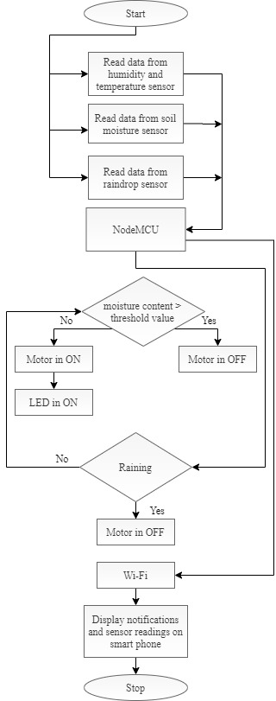

Fig. 1. Flow of the Smart Farming system.

1. IMPLEMENTATION OF SMART FARMING SYSTEM

The block diagram of proposed Smart Farming system using IoT is shown in Fig. 2:

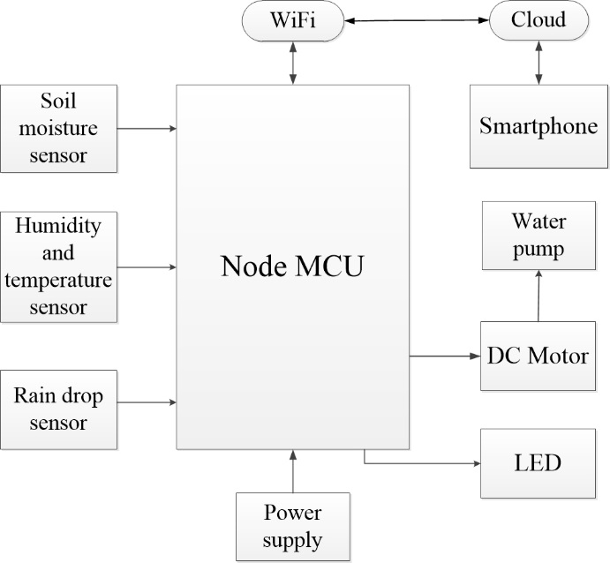

Fig. 2. Block diagram of the Smart Farming system.

Humidity and temperature sensor (DHT11) shown in Fig. 3, consists of a thermistor, humidity sensing component and an IC. Thermistor calculates the temperature of its surrounding medium from its capability of varying its resistance due to temperature. A moisture holding substrate is placed between two electrodes in humidity sensing component. The variation in humidity produces a variation in resistance between electrodes. The variation in resistance is measured and processed by the IC which gives the humidity value to the NodeMCU. This sensor operates at a voltage range of 3.3V to 5V. The range of temperature is 0 - 50°C, range of humidity is 20 - 90% RH.

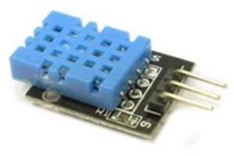

Fig. 3. Humidity and temperature sensor.

The Soil Moisture Sensor in Fig. 4 calculates the average of dielectric permittivity along the length of the sensor. Here, dielectric permittivity is function of water. The temperature range for the working of this sensor is 10 - 30°C and voltage applied is 5V.

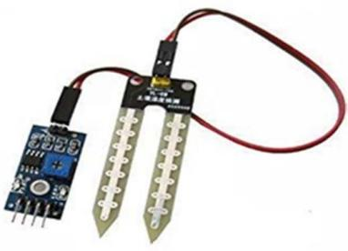

Fig. 4. Soil moisture sensor.

SCEECS 2020

In raindrop sensor shown in Fig. 5 as raindrops fall on the nickel lines the drop connects these lines in parallel which reduces the resistance and hence the voltage drop across the lines is also reduced. This happens because water is a good conductor of electricity. So when the voltage drop is less than a certain value it indicates that it’s raining. The module has a rain board, a control board, power indicator LED, and an adjustable sensitivity through a potentiometer. Its operating voltage is 5V. The range of resistance is from 100KOhm to 2MOhm.

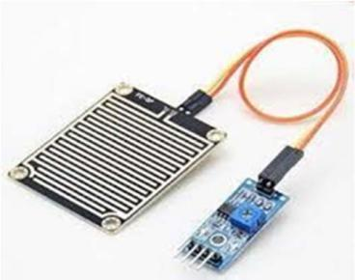

Fig. 5. Raindrop Sensor.

DC Motor in Fig. 6 converts DC electrical power into mechanical power. It works on the principle of Lorentz Law. The DC motor can move in both clockwise and anticlockwise directions depending on the sign of voltage applied between its terminals. The DC motor operates at a range of 3 to 9V and runs at a speed of 3000RPM.

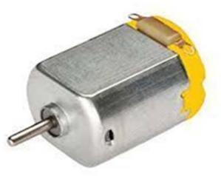

Fig. 6. DC motor.

NodeMCU in Fig. 7 is an open source IoT platform which includes firmware that runs on ESP8266 Wi-Fi module. Programming is done in Arduino IDE using C/C++ language or Lua script. NodeMCU has 16 GPIO pins which can be used to control other peripheral devices like sensors, LEDs, switches etc. These pins can also be used as PWM pins. It has two UART interfaces and uses XTOS operating system [7]. It can store 4M Bytes of data. The operating voltage of NodeMCU is 5V. It uses L106 32-bit processor, and the processor's speed is 80-160MHz.

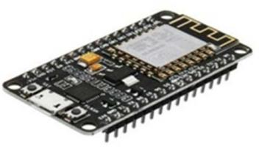

Fig. 7. NodeMCU.

Deek Robot in Fig. 8 acts as an interface to the output device DC motor. It is a current amplifier and so provides enough current to drive the DC motor [8]. Deek Robot has over temperature protection and it has internal clamp diodes. It has high noise immunity.

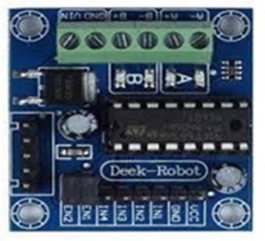

Fig. 8. Deek Robot.

Blynk is an open-source platform designed for IoT which can control hardware remotely, can display sensor data, can store data, visualize it. The components of this platform are a server which can be ran privately or use the common one, an app and libraries. Every time some information is given from the blynk app, the information travels to the blynk Cloud, from there it automatically find its way to the hardware. The connection between the cloud and the app can be through Wi-Fi, Bluetooth, GSM, Ethernet etc. The state of hardware pins can be manipulated by the commands given in the blynk app through various kinds of widgets present. Authentication token is generated after every project is created and it is a unique identifier which connects the hardware and the smartphone.

The data from Humidity and temperature sensor, raindrop sensor is sent to the digital pins of the NodeMCU. The data from Soil moisture sensor is sent to the analog pin of the NodeMCU. DC motor is connected to the NodeMCU via deek robot which is connected to two digital pins of NodeMCU. Serial monitor displays the data given by sensors if serial functions are written in the code and if serial communication between the NodeMCU and the device exists. Name of the Wi-Fi network and password are written along with the Authentication token in the code to connect the hardware to blynk app. When the code is dumped into the hardware, from then the status of the crops and soil along with the DC motor status is seen on smartphone when connected to Wi-Fi. The notifications received and the values of humidity, temperature and soil moisture in blynk for the Smart Farming system are as shown in the below figures Fig. 9, Fig. 10, Fig. 11 and Fig.

12. The model for the Smart Farming system is as shown in the figure Fig. 13.

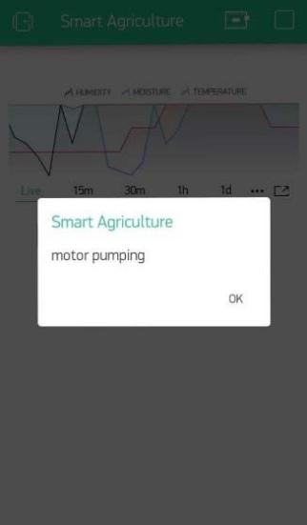

Fig. 9. Notification in blynk when the DC motor is pumping water to the crops at the farm.

SCEECS 2020

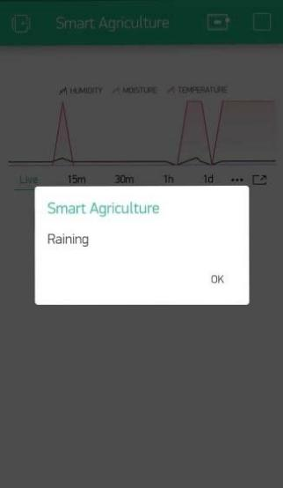

Fig. 10. Notification in blynk when there is rainfall at farm.

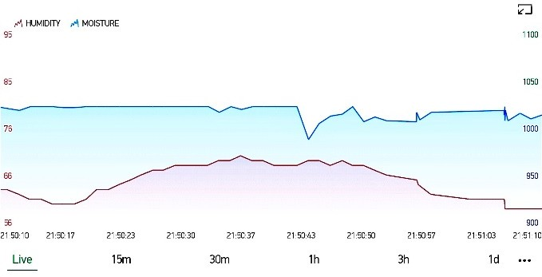

Fig. 11. Graph in blynk showing the values of humidity and moisture content in the soil of the farm.

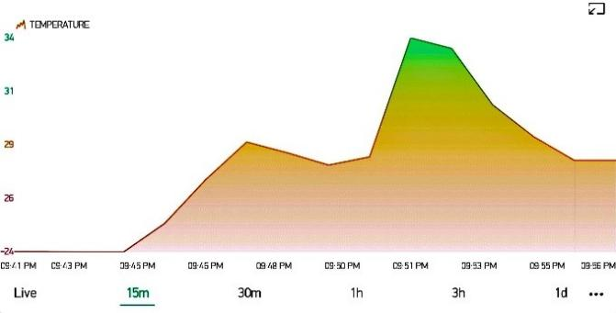

Fig. 12. Graph in blynk showing the values of temperature of the farm.

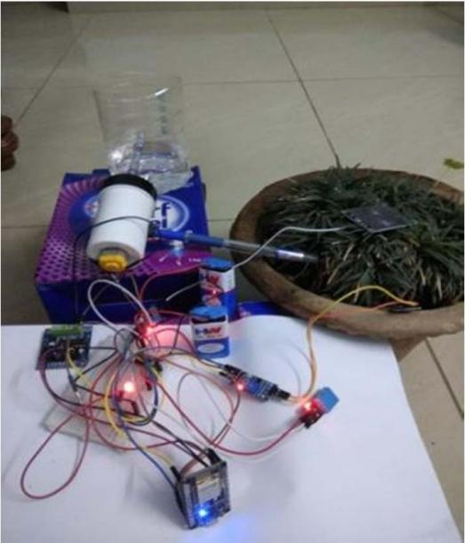

Fig. 13. Model of the Smart Farming system.

1. CONCLUSION

In this paper, IoT technology is used to sense and analyze the temperature, humidity level, soil moisture level and the rain condition and DC motor is controlled using NodeMCU. All these values are sent to the smart phone using Wi-Fi. Due to the usage of this system, adequate water is pumped and rain is also utilized efficiently. This system is very much helpful to farmers as they need to regularly pump water and check the status of each crop. From anywhere in the world, farmers can know the values of humidity, temperature and soil moisture and if the DC motor is ON through the blynk app present in their smartphones.

REFERENCES

1. Pradyumna Gokhale, Omkar Bhat, Sagar Bhat,"Introduction to IOT", International Advanced Research Journal in Science, Engineering and Technology (IARJ SET), Vol. 5, Issue 1, January 2018.
2. Brian Gilmore,"The Next Step in Internet Evolution: The Internet of Things", Internet of Things, cmswire, Jan 2014.
3. A.Anusha, A.Guptha, G.Sivanageswar Rao, Ravi Kumar Tenali, “A Model for Smart Agriculture Using IOT”, International Journal of Innovative Technology and Exploring Engineering (IJITEE),ISSN: 2278-3075, Volume-8 Issue-6, April 2019.
4. Muthunoori Naresh, P Munaswamy,” Smart Agriculture System using IoT Technology”, International Journal of Recent Technology and Engineering (IJRTE), ISSN: 2277-3878, Volume-7 Issue-5, January 2019.
5. Nikesh Gondchawar, Prof. Dr. R. S. Kawitkar, ”IOT based smart agriculture”, International Journal of Advanced Research in Computer and Communication Engineering, Vol. 5, Issue 6, June 2016.
6. Anand Nayyar, Er. Vikram Puri,” Smart Farming: IoT Based Smart Sensors Agriculture Stick for Live Temperature and Moisture Monitoring using Arduino, Cloud Computing & Solar Technology”, November 2016.
7. [www.wikipedia.org](http://www.wikipedia.org/)
8. Sweksha Goyal, Unnathi Mundra, Prof. Sahana Shetty,” SMART AGRICULTURE USING IOT”, International Journal of Computer Science and Mobile Computing, Vol.8 Issue.5, pg. 143-148, May 2019.

SCEECS 2020